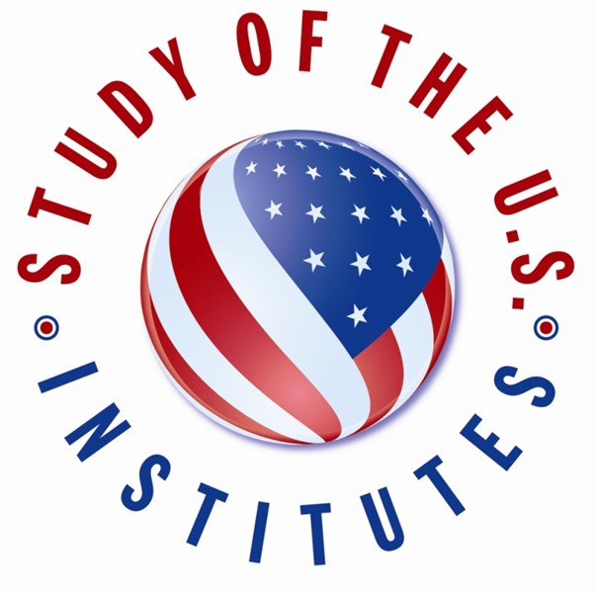
Study of the U.S. Institutes (SUSI) for Scholars

Application Form

Bosnia and Herzegovina

Submit Application form by e-mail to Bhexc@state.gov by November 30, 2022, at 11:59pm local time.

- Required

- Select the Theme of the SUSI Institute for Scholars: * (American Politics and Political Thought; Contemporary American Literature; Journalism and Media; U.S. Culture, Identity, and Society; U.S. Economics and Sustainable Development; or U.S. Foreign Policy).

SECTION A: CANDIDATE INFORMATION
Please provide information exactly as it appears in your passport.

- Surname (Last Name): *

- Given Name(s): *

- Sex: * (Female, Male, Non-binary, Other, please specify)

- Date of Birth: *

- City of Birth: *

- Country of Birth: *

Citizenship:

- Primary Citizenship: *

- Country of Residence: *

- Secondary Citizenship (if applicable):

Candidate Contact Information:

- Street Address: *

- City: *

- State/Province: *

- Postal Code:

- Country: *

- Phone Number: *
- Email Address: *

Medical, Physical, Dietary, or other Personal Considerations:
This will not affect a candidate's selection but will enable the host institution to make any necessary accommodations. Please indicate if the candidate has a disability.

- Please indicate if the candidate has a disability: * (Blind or visual Impairments, Deaf or Hearing Impairments, Learning Disability, Physical Disability, Psychiatric Disability, Systemic Disability, Other)

- Please describe any pre-existing medical conditions, including any prescription medication required, dietary restrictions, or personal considerations. *

Experience in the United States:

- Have you traveled to the United States before? *

- If yes, please list any previous travel to the United States for the purposes of tourism/vacation, conferences, educational study, or previous ECA related grants. Provide dates/duration, purpose of visit(s), and location. (Example: July 4-14, 2019 Tourism to Washington, D.C.; December 1-15 2018, Short Term Study Abroad to New York City, NY.)

- Have you ever participated in or been accepted into a U.S. Department of State sponsored program? (If yes, please proved program name and the dates)

- Family Residing in the United States (if applicable):
Please include relation information, city, and state. (Example: Jane Doe, sister- Denver, CO)

SECTION B: CANDIDATE BACKGROUND

- Education: *
Please list all earned degrees beginning with the most recent. Each entry should include the following information:

Degree Earned (Degrees should reflect the closest U.S. equivalent.) Year Awarded
Specialization Institution
(Example: Master's; 2019; International Relations; American University)

- Additional Academic/Professional Training/ Workshops: *

- Current Role/Job Title: *
- Institution/Organization Name: *

- Institution/Organization Country: *

- Work History: *
Please limit work experience to the FIVE most recent job positions. Please provide the following information for each entry:
Institution
Dates of Employment (Month/Year-Month/Year) Title/Position (please specify if part-time)

(Ex. American University; 01/2019-01/2020; Professor of International Relations)

- Professional Responsibilities: *
Candidates should discuss professional responsibilities in greater detail, including research interests, administrative responsibilities (example: curriculum design), and/or other pertinent information not included in the section above.

- Current Courses Taught: *
If you are not currently teaching courses, please indicate NOT APPLICABLE. Please include the following information for each course:
Course Title
Indicate Level of Students (Secondary School Students/Undergraduate Students/Graduate Students) Classroom Hours per Semester
Number of Students
% of U.S. Studies Content

- Current Student Advising:
Advising is not the same as teaching. If you advise students please input the number of students, their level, and hours you spend helping students clarify personal and career goals and evaluating progress toward those goals. This section can also include supervision of Ph.D. and graduate students.

Please include the following information:
Number of Students Advised Studying U.S.-Related Topics
Indicate Level of Students (Secondary School Students/Undergraduate Students/Graduate Students) Hours of Advising Per Student Per Year

- Publications Related to the Institute Theme:
Please list all foreign titles in English, including whether the publication was a book, chapter, journal article, newspaper article, etc. Please only list publications within the last five years.

- Active Memberships in Professional Associations:
Please limit to three most relevant. Provide the position and organization. (Example: President, Washington Educational Professionals Association.)

- Other Leadership Positions Beyond Professional Duties:
Please provide the activity, position/title, year started, year completed, and the description of duties.

- Potential Outcomes: *
Please select any likely potential professional outcomes of this program: (Create a new Course, Create a New Degree Program, School Curriculum Redesign, National Curriculum Redesign, New Research Project, New Publication, Professional promotion, Government of Ministry Policy, New Professional Organization, New Institutional Linkages, Raise Institutional Profile)

- Candidate Personal Statement: *
As part of the SUSI application process, candidates should submit a personal statement about their background and goals. In up to 500 words, the candidate should address the following questions and any other pertinent information:

Why are you interested in participating in the Institute? What do you hope to gain from the Institute?
What will you contribute to the Institute?
How will you leverage the experience to achieve "other potential outcomes" checked in the above section?
How will you amplify the impact of the program beyond your research and knowledge?

Please write your personal statement below.

